**Project assignment 1**

Rui Zhu, Lingjing Huang, Entisar Seedi M Alshammry

**44/50**

**Actor-Goal List**

|  |  |  |  |  |
| --- | --- | --- | --- | --- |
| Actor | Goal |  | Actor | Goal |
| Manager | Start system | Food supply system | Receive order |
| Close system | Administrator | Manage users |
| Cash in | Manage security |
| Cash out | Manage system tables |
| Customer | Make order | Sales Activity System | Analyze sales |
| Make payment | Performance data |

**Use Cases**

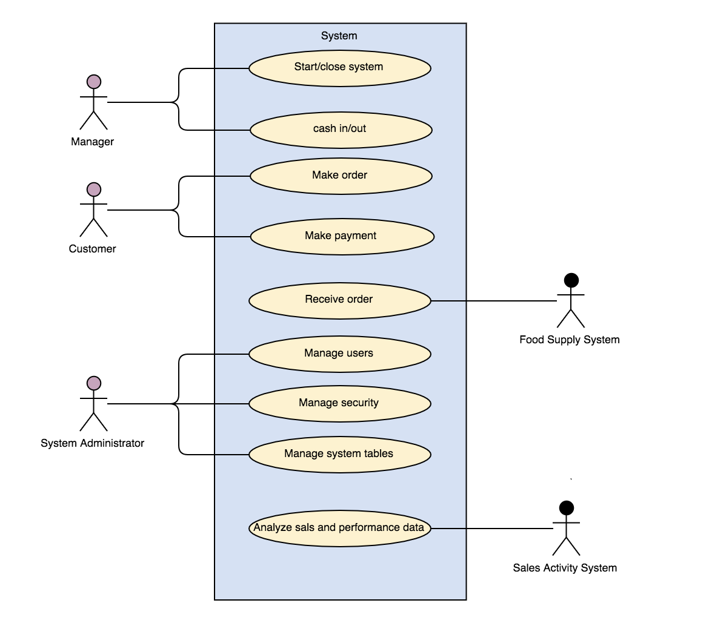

**Initial “fully dressed” version of “customer places order” Use Case**

**Use case: Customer Places order**

**Scope:** Health Castle vending machine application

**Level:** user goal

**Primary Actor:** Customer

**Stakeholders and Interests:**

* Customer: Wants easily visible display of entered items and prices. Wants user-friendly UI and fast service with minimal effort. Wants proof of purchase to support returns.
* Manager: wants to make sure have enough change in machine, wants the machine works normally.
* System Administrator: Wants to be able to quickly perform override operations, and easily debug system problems.
* Servant: wants to receive customer’s order easily.
* Sales Activity System: Wants to accurately record transactions and satisfy customer interests. Wants to ensure that Payment Authorization Service payment receivables are recorded. Wants some fault tolerance to allow sales capture even if server components are unavailable. Wants automatic and fast update of accounting and inventory.

**Preconditions:** The machine is started and normally working.

**Success Guarantee (or Postconditions):** Goods are enough to order. Sale is saved. Tax is correctly calculated. Accounting and Inventory are updated. Commissions recorded. Receipt is generated.

**Main Success Scenario (or Basic Flow):**

1. Customer arrives at vending machine.
2. Customer chooses the goods he/she wants.
3. System records sale line item and presents item description, price, and running total. Price calculated from a set of price rules.
4. System presents total with taxes calculated.
5. System tells Customer the total, and asks for payment.
6. Customer pays and System handles payment.
7. System logs completed sale and sends sale and payment information to the external Accounting system (for accounting and commissions) and Food supply system (to prepare for food).
8. System presents receipt and number plate.
9. Customer leaves with receipt and number plate.

**Extensions (or Alternative Flows):**

1. Invalid item ID (not found in system).
2. Cannot connect to the external Accounting system.
3. Run out of changes.
4. Wrong pictures or prices of the goods.
5. …

**Special Requirements:**

- Touch screen UI on a large flat panel monitor.

- Credit authorization response within 30 seconds 90% of the time.

- …

**Technology and Data Variations List:**

**Frequency of Occurrence:** Could be nearly continuous.